[M1] – Reading Assignment
- Visit Nikon’s comprehensive website on www.microscopyu.com/articles/formulas/
  - Suggested readings
    - Numerical Aperture
    - Resolution
    - Field of View
  - Interactive tutorials
    - Numerical Aperture and Image Resolution
    - Microscope Conjugate Planes
    - Alignment of Kohler Illumination
- Read about Fluorescence Microscopy www.microscopyu.com/articles/flourescence/index.html
  - Fluorescence microscopy leads the world of microscopy for its ability to detect regions of the biological sample through protein staining.
  - Use the interactive tools to see how changing parameters changes the image quality.
    - Laser Scanning Confocal Microscopy
  - Further suggested readings
    - Confocal microscopy; more @ www.microscopyu.com/articles/confocal/confocalintrobasics.html
    - Introduction of fluorescent proteins
- Attached PDF for any further clarification of concepts
[M2] – Simple Laser Illumination Paths
- Introduction of Lasers
  - LASER stands for Light Amplified Stimulation Emission Radiation
    - If starting with a “true” laser then the source is expected to be a coherent source. Read about coherence @ www.rp-photonics.com/coherence.html
      - Spatial Coherence
      - Temporal Coherence
    - Quick tutorial of how lasers work @ inventors.about.com/od/lstartinventions/ss/LaserWorks.htm
- Beam Path Tuning
  - Starting at the laser source there needs to be at least 2 mirrors in order to correct the manufacturing and user errors of laser head placement.
    - 1 mirror does not allow for such corrections as demonstrated below.

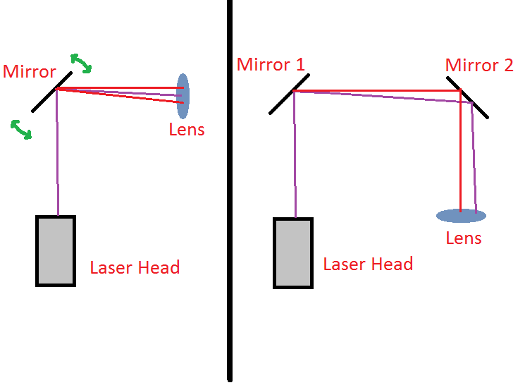
Figure 1: On the left hand side there is only one mirror to adjust the beam path of the laser. Since the components have to be bolted down their geometry is fixed. As is evident one mirror cannot correct the beam path in order for it to be paraxial with the lens. Lacking paraxiality causes aberrations in the path and correcting the beam path for the second optical component becomes even harder. On the right hand side there are 2 mirrors prior to first lens. Although the beam is still shifted to the left is in the first case the beam can undergo 2 rotations in order to make the beam paraxial to the first lens.
- Beam Expansion
  - After aligning the beam other common steps are beam expansion or contraction.
    - Both sides of the same coin as with acceleration and deceleration.
    - Lenses are usually produced as spherical approximations because they are easy to manufacture.
    - Lenses without spherical aberration have a parabolic shape.
  - Requirements for proper expansion:
    - An expansion is simply the ratio of the lenses used.
    - The lenses to be used are place at the addition of the focal lengths apart assuming the incoming light source is collimated.
  - Examples.
    - 2x expansion is made using 2 lenses whose ratio is 2 (i.e 100mm and 200mm) placed 300mm apart.
    - 1.5x expansion is made using 2 lenses whose ratio is 1.5 (i.e 100mm and 150mm) placed 250mm apart.
    - 0.5x expansion (or 2x contraction) is the reciprocal of a 2x expansion.
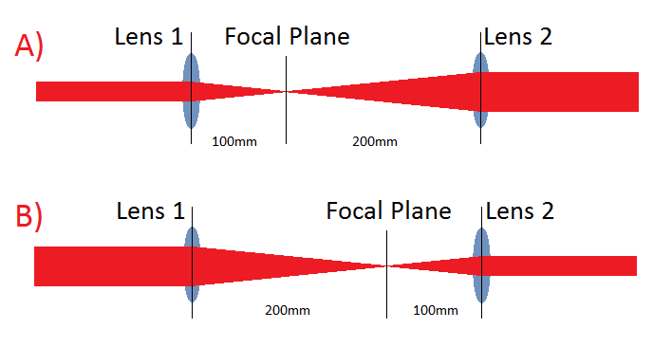
Figure 2: A) is a 2x beam expansion using a 100mm and 200mm lens. Using a collimated beam source we expand the beam by placing the lenses at their focal lengths apart. B) In order to contract the beam by a factor of 2 the lenses are flipped and the 200mm lens is place first.
- Creating a Thin Laser Line
  - Concept essentially the same in part 3 of [M2]. Instead of using a spherical lens a cylindrical lens is used.
  - Cylindrical lenses are identical to spherical lenses but in only 1 dimension.
    - The azimuthal direction is the only changing parameter as the light enters the lens.
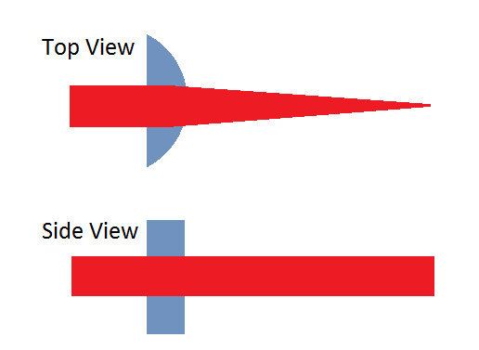
Figure 3: A cylindrical lens is a great way of creating a laser line because it only contracts a light source in 1 dimension while leaving the other dimension untouched (i.e for Line-Confocal or simply as a stimulation barrier for C. elegans).
- Measure of Light Intensity and Wavelength
  - In order to accurately measure the intensity (power per unit area) of the light a device known as a power meter is used.
    - Power meter – Thorlabs PM100
    - Power sensor – S121B for visible light wavelengths only!
    - Other order power sensor for IR measurement
  - To operate the sensor correctly follow the steps below
    - Clear the power sensor by zeroing it to the conditions under which you will be using it. Menu Settings>UserCalibration/DarkZeroing>enter>enter
    - Place the sensor in the path of the beam and hit start.
    - Reset the power meter once or twice to ensure the measurement is correct.
    - Repeat step iii as many times as desired to obtain more data points.
[M3] – Simple Detection
- One can either design a microscope to make the specimen viewable by the eyes or by a detection device called a CCD or CMOS camera.
  - Simplest microscope to have a CCD detection camera consists of 2 components.
    - Objective
    - Tube lens
    - CCD
  - CCD and CMOS cameras are designed to use a 200mm tube lens to focus the image onto the sensor. This is where the real image of the specimen is focused.
  - The tube lens can be altered to any size you want in order to magnify or demagnify the image further.
    - Example: If you use a 100mm lens the image will focus sooner than with a 200mm lens therefore the image will have been demagnified.
    - Easy way to remember the level of demagnification is to take the ratio of the tube lens being used to the 200mm standard tube lens.
      - Magnification = tubeLens/200mm
      - Example: 100mm/200mm = ½ therefore the image has been demagnified by ½ after the objective magnification
    - Remember this is the magnification of the image after the magnification of the objective.
    - Total magnification is objective magnification * tube lens magnification
      - Example: 10X obecjtive * 1/2tube lens mag = 5X effective magnification
- Below is the design of a simple microscope with a 10X objective and CCD camera
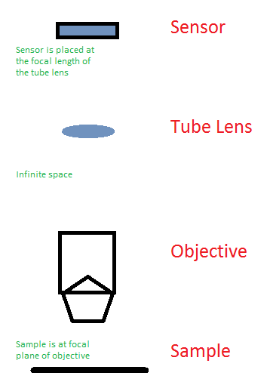
- In the infinite space area of the objective optical components can be added without affecting the image of the sample.
  - Optical components include:
    - Dichroic mirrors – mirrors that have cutoff wavelength transmissions
      - Stimulation sources
      - Illumination light
      - Split color channels to have more than 1 camera
    - Adjustable apertures
      - To remove out of focus light
      - Increase depth of field
- Green laser beam insertion and measurement
  - As stated in the previous section of this module dichroic mirrors can be inserted into the infinite space region for stimulation/illumination sources or for channel splitting
  - A green 532nm laser will be inserted into the beam path for stimulation purposes.
    - A dichroic mirror that reflects 532nm and transmits higher wavelengths will be required.
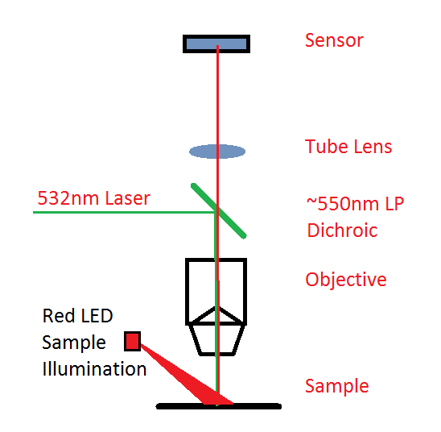
- Beam size measurement
  - A stimulation source is useless if there is no way of characterizing it.
  - To characterize the beam the size of the beam spot must be measured
    - Place a very reflective material (i.e. white card/paper) at the focal plane of the objective and shine the stimulation source on it.
    - Detect it with the camera
    - The beam should be of Gaussian form so fit a 2D Gaussian onto the image
    - Normalize the Gaussian image (i.e. divide by max value of image) and apply a new normalization constant A
      - A = Power/(2*pi*sigmaX*sigmaY)
    - Now you have an intensity beam profile as a function of space.
[M4] – Dissection Microscope
- A dissection microscope is essentially the same microscope that was created in the previous module. One key difference is that we will instead illuminate the sample using a 470nm Blue light source in order to see GFP fluorescence.
- Differences:
  - Expand the light as much as possible and then focus the light into the back focal plane of objective so that it comes out parallel and covers the entire sample.

