The following is a tutorial on image processing in Adobe After Effects CC 2014

Creating A New Composition
Composition New Composition… (Shortcut: ‘Ctrl-N’)

Composition Name: ______ Ex: PT23, F6, NC12…etc
Width: 2048 px √ Lock Aspect Ratio
Height: 2048 px

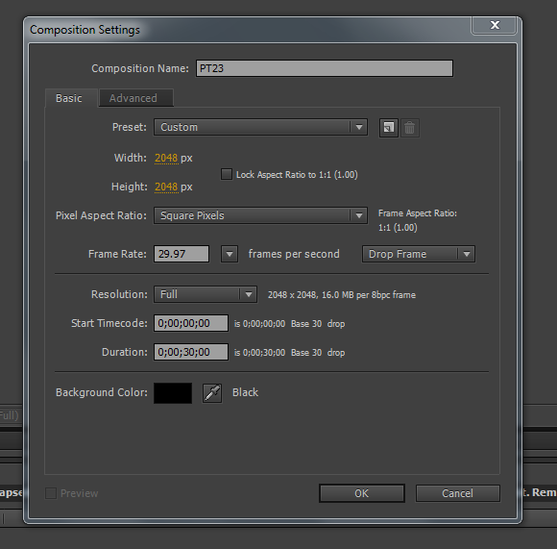
Double Click under ‘Project’ window underneath Composition Name to pull up image sequence.
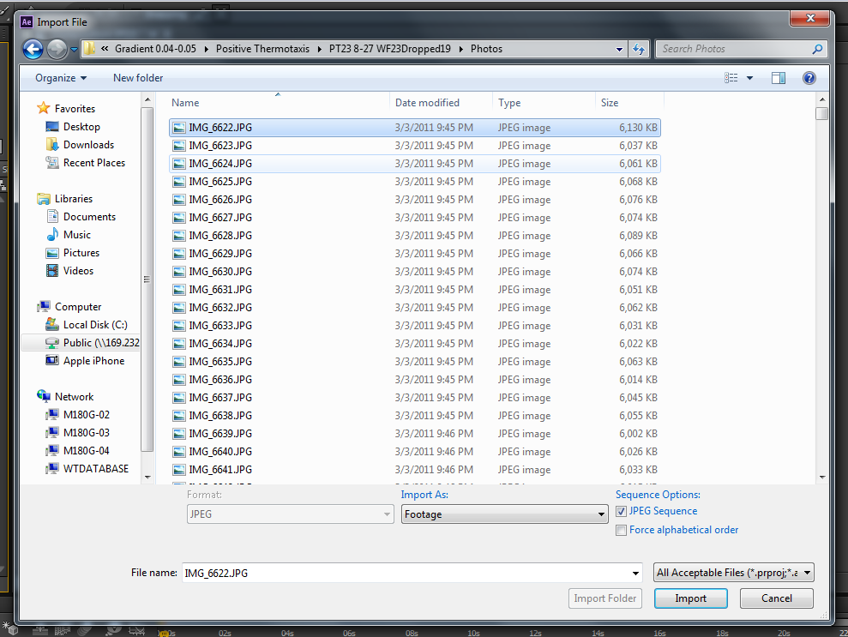
Click on the first Image in the folder, and Import the JPEG Sequence
Drag Image Sequence down to the Composition Work Area
Scale (Shortcut: ‘s’) Scale the image so that just the edges of the plate are cut off. Do not cut off more or else the pixel/mm conversion will be off. For thermotaxis, 66.0,66.0% is the ideal.
Rotation (Shortcut: ‘r’) This may not be necessary for every video…

Creating Adjustment Layers
Create New Adjustment Layer (Shortcut: ‘Ctrl-Alt-y’)
Effect Color Correction Brightness and Contrast
Brightness: 0
Contrast: 100
Effect Color Correction Auto Contrast
Black Clip: ___ Play around with the black clip, although it does not always need to be adjusted.
White Clip: 0.10%
Effect Color Correction Brightness and Contrast
Brightness: 0
Contrast: 100
Mask: Select the Rounded Rectangle Tool and create a mask on the Composition. Masks will isolate the effects within the created mask. In this case, create a mask to capture the darkest center area, where the contrast is consistent.

The brightness in the bottom right corner is what you want to cut out of the mask. 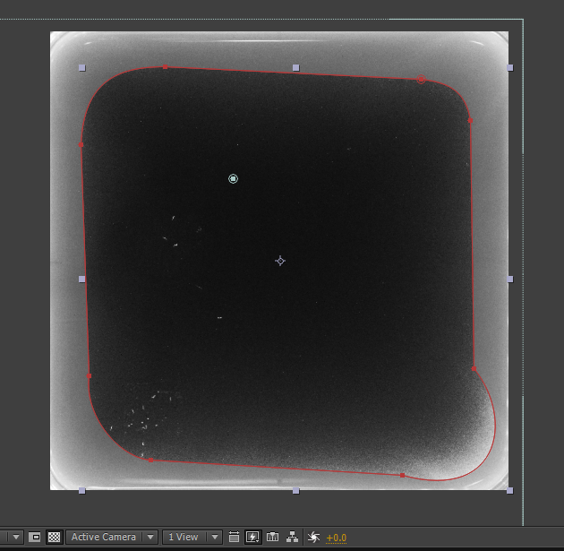

Expand the mask and adjust the Feather and Expansion
Mask Feather: ___ pixels These should remain around 100 pixels
Mask Expansion: ___ pixels
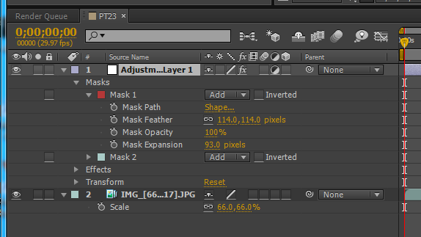

Copy and Paste the whole Adjustment Layer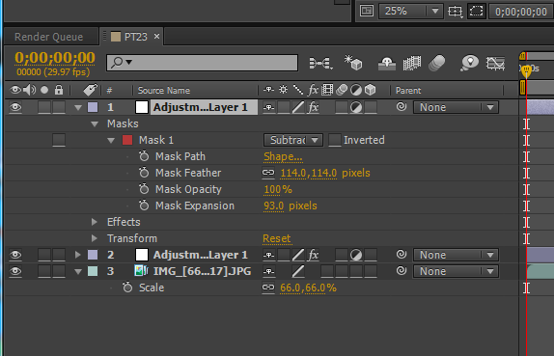
Change the mask from Add to Subtract. This will apply the effects of the mask in the area outside of the mask (whereas the Add option applies the effects to the areas enclosed).
Expand the ‘Effects’ to adjust the ‘Brightness and Contrast’, as well as the ‘Mask Feather’ and ‘Mask Expansion’ to create a smooth transition between the two Adjustment Layers.
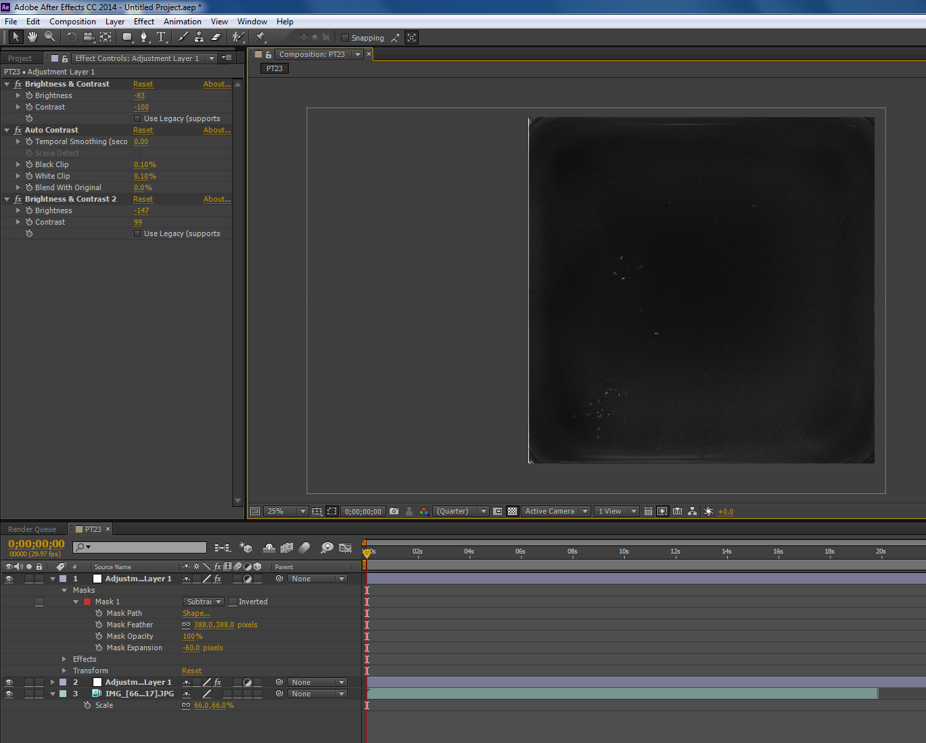

Optional Funtions: You may not need to use all of these, but they are helpful to know depending on the specific image sequence you are dealing with.
Solid Layer (Shortcut: ‘Ctrl-y’) This creates, as the name implies, a solid layer. You may need to use this layer if there are still very bright corners or edges that are comparable to the brightness of the worms.
Use the color picking tool to select a dark color similar to the darkest part of the plate. (You can always adjust the opacity to blend it closer to the actual color of the plate)
Create a Mask (Rounded Rectangle Tool) to cut off the outermost corners.
You want to make this mask covering as little of the plate as possible. Since it is a solid layer, any worms that crawl underneath this layer will not appear during the tracking.
Again, play with the ‘Mask Feather’, ‘Mask Opacity’, and ‘Mask Expansion’.

Gradient Ramp
A gradient ramp can be created to compensate for uneven lighting. For instance, if the center of the plate is notably darker than the outer edges, you can create a radial gradient light in the center, and dark around the edges.
Create New Adjustment Layer (Shortcut: ‘Ctrl-Alt-y’)
Effect Generate Gradient Ramp
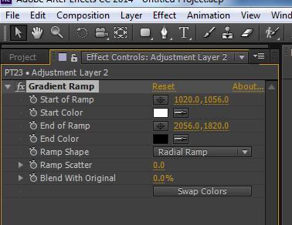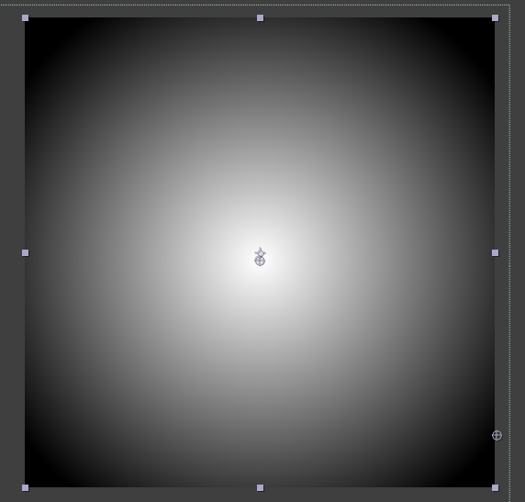
After you have selected the ‘Start of Ramp/Color’ and ‘End of Ramp/Color’, Adjust
‘Blend With Original’ ____ Keep the percentage high, ~80-95%.

Bilateral Blur
Bilateral blur essentially blurs the background while keeping objects in the foreground. This is helpful if there is dust or bright pixels that are on the plate that may be confused as worms during tracking.
However, using bilateral blur will increase the rendering time from ~15 minutes to around~ 1hour 15minutes.
Also, if you choose to use Bilateral Blur, add this effect LAST. Otherwise, the computer will lag if you continue to edit. Or, if you need to make adjustments, turn the effect off.
Create New Adjustment Layer (Shortcut: ‘Ctrl-Alt-y’)
Effect Blur & Sharpen Bilateral Blur
Generally, you do not need to change the Radius or Threshold.

Invert
If the image is dark worms on a bright background (i.e. free motion), you will need to invert the colors so that it is bright worms on a dark background.
Create New Adjustment Layer (Shortcut: ‘Ctrl-Alt-y’)
Effect Channel Invert

Finishing the Composition

End the workspace by dragging the bar to match the end of the image sequence. Press SHIFT while you drag the end area so that it snaps to the end.
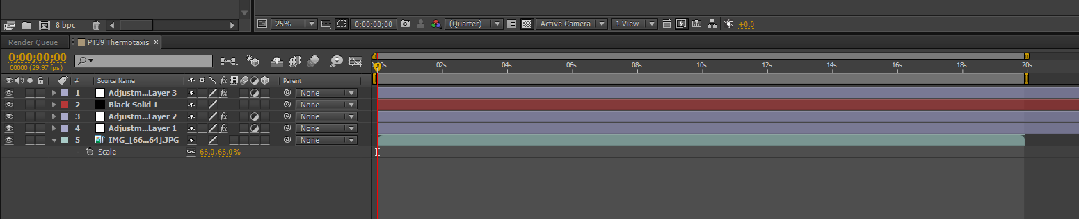
Composition Add to Render Queue (Shortcut: ‘Ctrl-m’)
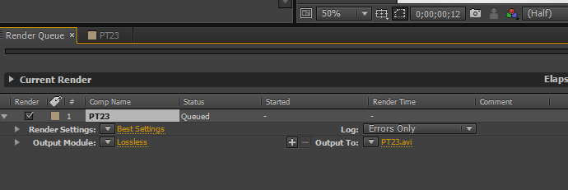

Make sure to Output the video onto the LOCAL computer, NOT the cloud/WTDatabase.
Also, the Output file should be .avi format. If it is not (this happens when you image process on a Mac), save the project as an .aep file and upload it onto the cloud, and then render the video on one of the computers here.

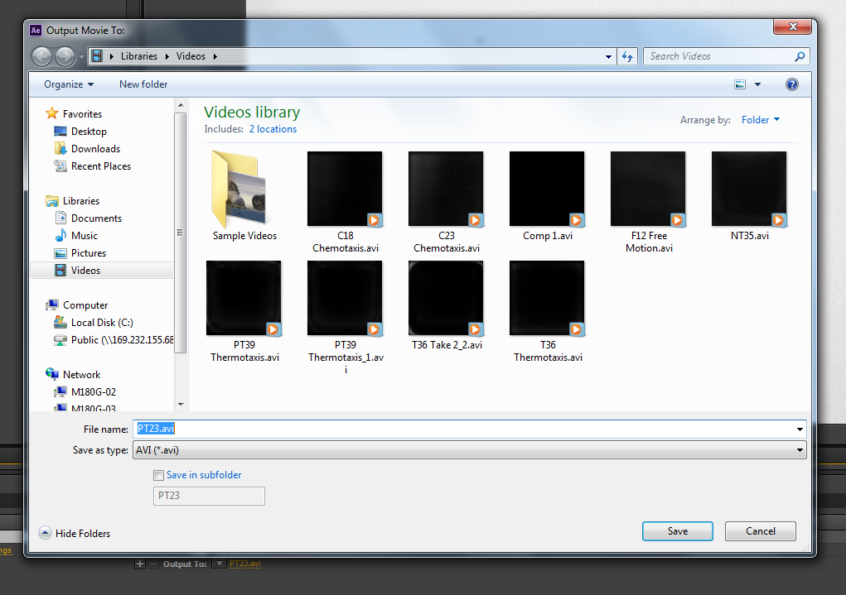
Then RENDER the video and wait. And wait. And wait.

After the video is done rendering, track the worms on the local computer, using the video file under Libraries/Videos.
After tracking is complete, move the .avi file onto the cloud, and you are DONE!

Miscellaneous

The order in which you place the layer matters! Each additional layer will place the effects on top of the previous layers.
Brightness and Contrast is your best friend. You can continue to add additional layers on until the image becomes black and white.
You can delete the video off of the local computer to free up space, if necessary.

